Session 2026-2027

Vision:Dream of where you want. | Mission: Means to achieve Vision

Program Educational Objectives of the program (PEO): (broad statements that describe the professional and career accomplishments)
PEO1 | Preparation | P: Preparation | Pep-CL abbreviation  pronounce as Pep-si-lL easy to recall
PEO2 | Core Competence | E: Environment (Learning Environment) | Pep-CL abbreviation  pronounce as Pep-si-lL easy to recall
PEO3 | Breadth | P: Professionalism | Pep-CL abbreviation  pronounce as Pep-si-lL easy to recall
PEO4 | Professionalism | C: Core Competence | Pep-CL abbreviation  pronounce as Pep-si-lL easy to recall
PEO5 | Learning Environment | L: Breadth (Learning in diverse areas) | Pep-CL abbreviation  pronounce as Pep-si-lL easy to recall

Program Outcomes (PO): (statements that describe what a student should be able to do and know by the end of a program)
Keywords of POs:
Engineering knowledge,Problem analysis, Design/development of solutions,Conduct Investigations of Complex Problems, Engineering Tool Usage, The Engineer and The World,Ethics, Individual and Collaborative Team work,Communication, Project Management and Finance, Life-Long Learning

PSO Keywords: Cutting edge technologies, Research

“I am an engineer, and I know how to apply engineering knowledge to investigate, analyse and design solutions to complex problems using tools for entire world following all ethics in a collaborative way with proper management skills throughout my life.” to contribute to the development of cutting-edge technologies and Research.

Integrity: I will adhere to the Laboratory Code of Conduct and ethics in its entirety.

Name and Signature of Student and Date
(Signature and Date in Handwritten)

Session | 2026-27 (ODD) |  | Course Name | Web Technology Lab
Semester | 3 |  | Course Code | 23CT1301
Roll No | 65 |  | Name of Student | Shubham Dnyaneshwar Umredkar
Practical Number |  | 5
Course Outcome |  | - Understand various internet technologies.  - Design the web pages using HTML and CSS.  - Implement the XML technology to store the data.  - Develop the interactive web pages using JavaScript.
Aim |  | JavaScript — Events &amp; Interactivity
Problem Definition |  | Build an interactive Calculator that responds to button clicks and key presses and updates the result dynamically.
Theory  (100 words) |  | JavaScript events are actions that occur when a user interacts with a web page. Examples of events include mouse clicks, key presses, form submission, and button presses. JavaScript event handling allows a web page to respond to these actions and make the page interactive. In this practical, a simple calculator is created using HTML and JavaScript. The calculator accepts numbers and operators through button clicks and keyboard input. Event handlers are used to perform calculations, clear the display, and delete values. DOM manipulation is also used to update the calculator display dynamically without reloading the webpage.
Procedure and Execution  (100 Words) |  | Step for Implementation:  ise likho:  - Create index.html and script.js files.  - Create the calculator layout with number and operator buttons.  - Create a function to add numbers and operators to the display.  - Create functions to clear, delete, and calculate the result.  - Add click events to call these functions.  - Add a keyboard event for user input.  - Run the calculator in the browser and test it.
Code:
HTML:
<!DOCTYPE html>
<html>
<head>
<title>JavaScript Calculator</title>
</head>

<body>

<h1>Calculator</h1>

<input type="text" id="display" readonly>

<br><br>

<button onclick="clearDisplay()">C</button>
<button onclick="deleteLast()">DEL</button>
<button onclick="addValue('/')">/</button>
<button onclick="addValue('*')">*</button>

<br><br>

<button onclick="addValue('7')">7</button>
<button onclick="addValue('8')">8</button>
<button onclick="addValue('9')">9</button>
<button onclick="addValue('-')">-</button>

<br><br>

<button onclick="addValue('4')">4</button>
<button onclick="addValue('5')">5</button>
<button onclick="addValue('6')">6</button>
<button onclick="addValue('+')">+</button>

<br><br>

<button onclick="addValue('1')">1</button>
<button onclick="addValue('2')">2</button>
<button onclick="addValue('3')">3</button>
<button onclick="calculate()">=</button>

<br><br>

<button onclick="addValue('0')">0</button>
<button onclick="addValue('.')">.</button>

<p id="message"></p>

<script src="Practicle_5.js"></script>

</body>
</html>
Javascript:

const display = document.getElementById("display");
const message = document.getElementById("message");

function addValue(value) {
display.value = display.value + value;
}

function clearDisplay() {
display.value = "";
message.innerText = "";
}

function deleteLast() {
display.value = display.value.slice(0, -1);
}

function calculate() {

if (display.value === "") {
message.innerText = "Please enter a calculation";
return;
}

try {
let result = eval(display.value);

display.value = result;
message.innerText = "Calculation Successful";
}
catch (error) {
message.innerText = "Invalid Calculation";
}
}

document.addEventListener("keydown", function(event) {

const key = event.key;

if (
(key >= "0" && key <= "9") ||
key === "+" ||
key === "-" ||
key === "*" ||
key === "/" ||
key === "."
) {
addValue(key);
}

else if (key === "Enter") {
calculate();
}

else if (key === "Backspace") {
deleteLast();
}

else if (key === "Escape") {
clearDisplay();
}

});

Output:
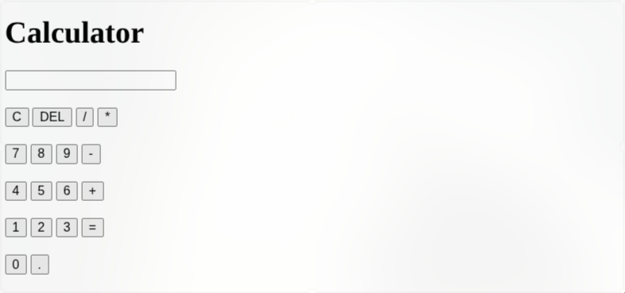
Output Analysis |  | The calculator accepts input through button clicks and keyboard keys. When the user enters numbers and operators, they are displayed on the screen. Pressing the = button or Enter key calculates and displays the result. The C button clears the display, while DEL or Backspace removes the last entered value. The output updates dynamically using JavaScript without reloading the webpage.
Link of student Github profile where lab assignment has been uploaded |  | https://github.com/shubham07-codes/Web-Technology-Lab
Conclusion |  | In this practical, I learned how to use JavaScript click and keyboard events to create an interactive calculator and dynamically update the webpage.
Plag Report (Similarity index < 12%)
Date |  | 22/09/26

